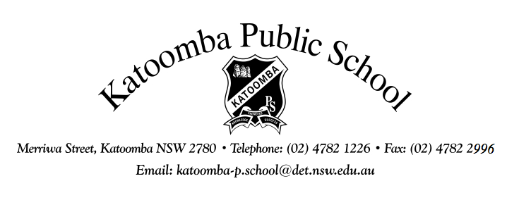
Merriwa Street, Katoomba NSW 2780 Telephone: (02) 4782 1226 Fax: (02) 4782 2996
Email: katoomba-p.school@det.nsw.edu.au
Website: http://www.katoomba-p.schools.nsw.gov.au

Dear Parents/Carers,
LOCAL EXCURSIONS
At times, the school organises walking excursions around the local area which relate to work being undertaken at school.
A permission note is needed for children to undertake these activities off the school premises. This does not include excursions involving proximity to water or cliff faces, or activities involving bus or car travel.
Please fill in the permission note below and return it to the school as soon as possible.
Yours sincerely,
Fiona Paine
Principal
.........................................................................................................................................................

LOCAL EXCURSIONS

I give permission for my son /daughter ___________________________________of class _____ to undertake local excursions. I understand these will not involve transport by motor vehicles.

Signed: Date:
(Parent/Carer)

