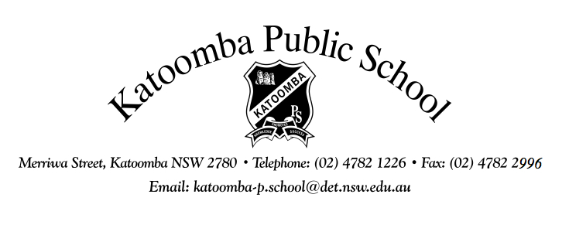
Merriwa Street, Katoomba NSW 2780 Telephone: (02) 4782 1226 Fax: (02) 4782 2996
Email: katoomba-p.school@det.nsw.edu.au
Website: http://www.katoomba-p.schools.nsw.gov.au

Dear Parents/Carers,
MEDIA CONSENT FORM
Throughout the year we have numerous activities at our school which are sometimes reported in local publications. In order to have student names/photos released to the media we need your permission. The terms of the permission to photograph on your child's enrolment form are too narrow to adequately cover the scope of activities within the community of Katoomba Public School.

If you are happy for your child to be photographed, please complete and return this Media Consent Form to the school as soon as possible.

If you choose NOT to return this form, your child's name will be recorded as "No, never photograph" even though you may have indicated permission on your child's enrolment form.
.........................................................................................................................................................

MEDIA CONSENT FORM
I hereby consent to my child _____________________________________________
who currently attends Katoomba Public School being photographed/filmed and/or identified for publications within the NSW Department of Education & Training's newspaper, external publications, internet site, television, school newsletter and information pamphlets and on other associated promotional material (e.g. the school notice board facing Ada Street).

This Media Consent Form will remain valid for the duration of your child's attendance at Katoomba Public School or until rescinded in writing by you.
I understand that if I wish to withdraw my consent for the above, I will inform the school in writing.
Signed: Date:
Parent/Carer

