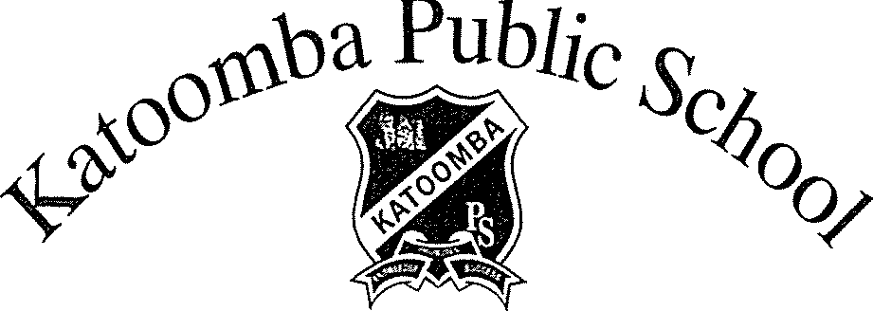
Merriwa Street, Katoomba NSW 2780 • Telephone: (02) 4782 1226 • Fax: (02) 4782 2996
Email: katoomba-p.school@det.nsw.edu.au
Special Religious Education & Special Education in Ethics Participation Form
A feature of the public education system in NSW is the opportunity to provide time in class for education in ethics, faith and morality from a religious or non-religious perspective at the choice of parents.

The school website www.katoomba-p.schools.nsw.edu.au provides information on these options to support parent/carer choice.

A parent/carer may at any time notify the school in writing that they wish to change their decision. Students will continue the same arrangement as the previous year, unless a parent/carer has requested a change in writing.

For more information about Special Religious Education (SRE) and Special Education in Ethics (SEE), including the list of approved providers, please visit: https://education.nsw.gov.au/teaching­ and-learning/curriculum/learning-across-the-curriculum/religion-and-ethics

If your preferred SRE or SEE option is not available please contact the approved provider. Students not attending SRE or SEE are given supervised alternative meaningful activities.

The following options are available at Katoomba Public School. Please choose one.

SRE Options

- Option 1: Catholic
- Option 2: Protestant OR
- Please check this box if you do not wish for your child to attend SRE. Your child will participate in alternative meaningful activities.

SEE Option - If you have declined for your child to attend SRE above please check below if you would like your child to attend SEE (Special Education in Ethics).
- Special Education in Ethics

Student name: Year:

Signature of parent/carer: Date: _

